Firmware Flash Instruction

1、Decompression the "FLASH" file,and copy those three files to your SD card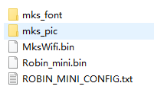

2、Insert TF card to screen

3、Turn off and turn on the printer ,it will auto flashing,when it finished,check it again ,thanks!